Find the range of each function for the given domain.
1. | R= _____________________ | $$g(x)= -2x -1 ; D=\{-3, -2, 5\}$$
2. | R= _____________________ | $$g(x)=2x^{2}-6 ; D=\{-3, -4, 5\}$$
3. | R= _____________________ | $$f(x)=(x-2){}^{2} ; D=\{-4, 0, 4\}$$

If $f(x)=3x-1,$ and $g(x)=x^{2}+1$, find the following:
4. | $f(3)=$____________________ | 5. | $g(3)=$____________________
6. | $f(-1)+g(4)=$_____________ | 7. | $g(-4)+f(-2)=$____________________

For $g=\{(-5,2), (-4,-1), (3,-8), (-2,0), (4,-9)\}$find the indicated values.
8. | $g(-4)=$___________________ | 9. | $g(4)=$____________________
10. | $g(x)=-1, x=$__________ | 11. | $g(x)=2, x=$__________

Find the following:
12. | Ordered pairs:  D=___________________  R=___________________  Function? ____________ | 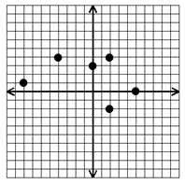

13. _________ | 