Represent the relation shown in the graph as indicated:
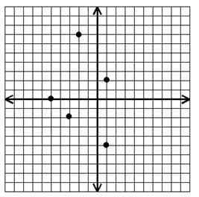
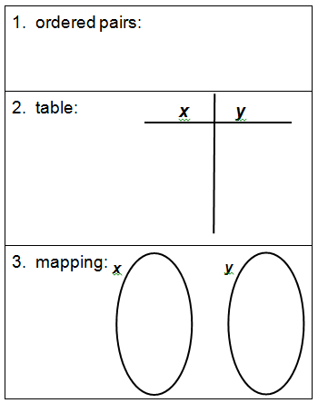
Draw a mapping and a graph for each relation:
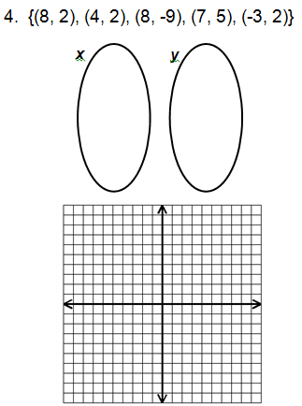
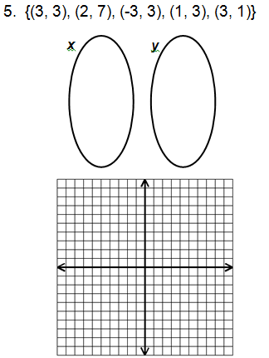

For each relation, state the domain and range, and tell if it’s a function.
6. | D= ___________________________  R= ___________________________  Function? ________ | {(0, 2), (-3, 1), (4, -5), (7, 4)}
Express the relations shown in each table, mapping, or graph as a set of ordered pairs. Then state the domain and range. Tell whether the relation is a function.
8. | Ordered Pairs: ____________________________________________________________  D= ___________________________  R= ___________________________  Function? ________ | 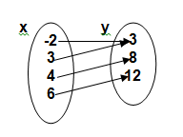
9. | Ordered Pairs:  ____________________________________________________________  D= ___________________________  R= ___________________________  Function? ________ | 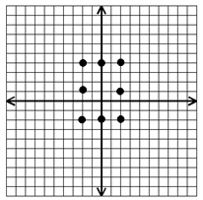
10. | Ordered Pairs:  ____________________________________________________________  D= ___________________________  R= ___________________________  Function? ________ | 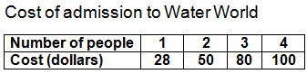
11. | Determine whether or not each graph is a function.  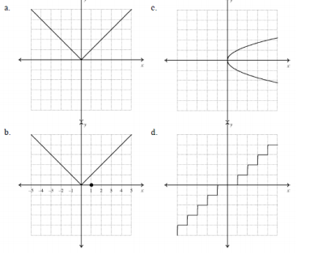 | A. ____________________  B. ____________________  C. ____________________  D. ____________________

