Name Class Date

1-2

**Practice**



Scatter Plots and Trend Lines

**For each table, make a scatter plot of the data. Describe the type of correlation**

**the scatter plot shows. Don’t forget to label your axes.**

|  |  |
| --- | --- |
| **1.** |  |



**2.**

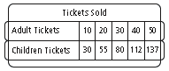 

**Use the table below and a graphing calculator for Exercises 3 through 6.**

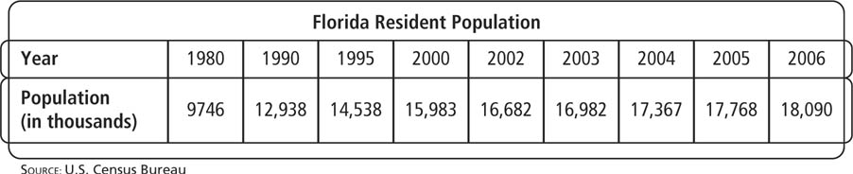

**3.** Make a scatter plot of the data pairs (years since 1980, population).



**4.** Draw the line of best fit for the data.

**5.** Write an equation for the trend line.

**6.** According to the data, predict the estimated resident population in Florida in  
2020.

Name Class Date

3-8

**Practice** (continued) *Form G*



Scatter Plots and Trend Lines

**Use the table below and a graphing calculator for Exercises 7 through 10.**

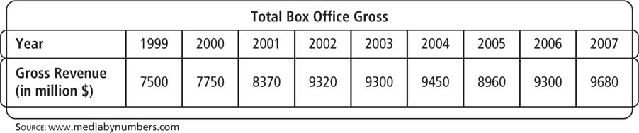

**7.** Make a scatter plot of the data pairs (years since 1999, revenue).

**8.** Draw the line of best fit for the data.

**9.** Write an equation for the line of best fit.

**10.** According to the data, predict the estimated gross revenue in 2015.

**In each situation, tell whether a correlation is likely. If it is, tell whether the  
correlation reflects a causal relationship or an association. Explain your reasoning.**

**11.** the number of practice free throws you take and the number of free throws you  
make in a game

**12.** the height of a mountain and the average elevation of the state it is in

**13.** the number of hours worked and an employee’s wages

**14.** a drop in the price of a barrel of oil and the amount of gasoline sold

**15.** **Open-Ended** Describe a real world situation that would show a strong  
negative correlation. Explain your reasoning.

**16.** **Writing** Describe the difference between interpolation and extrapolation. Explain  
how both could be useful.

**17.** **Writing** Describe how the slope of a line relates to a trend line. What does the   
*y-*intercept represent?

**Pearson Texas Algebra I**

Copyright © by Pearson Education, Inc., or its affiliates. All Rights Reserved.