Name _____________________________ Period ______ Date ____________

0.3 Worksheet: Modeling Real World Situations with Linear Equations

1 – 6: Given the following graphs, a) write the equation of the line and b) interpret the slope.

1. 2. 3.
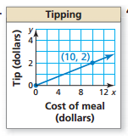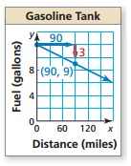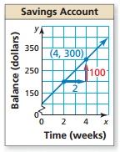
1.a) _______________ 2.a) ________________ 3.a) _______________

b) _________________ b) _________________ b) ________________

___________________ ___________________ __________________

___________________ ___________________ __________________

4. 5. 6.
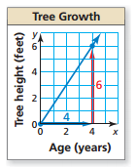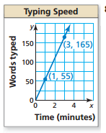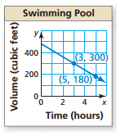

4.a) _______________ 5.a) ________________ 6.a) _______________

b) _________________ b) _________________ b) ________________

___________________ ___________________ __________________

___________________ ___________________ __________________

7 – 8: True or False. Given the following graphs, are the statements interpreting the slope true? If they are false, correct the error.

7. 8.
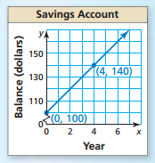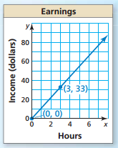

7. Statement: The slope of the line is 10, so after 7 years the balance in the savings account is $70.

True or False: ____________
If false, what should the statement be?

_______________________________

_______________________________

8. Statement: The slope is 3, so the income is $3 per hour.

True or False: ____________
If false, what should the statement be?

_______________________________

_______________________________

9. Two newspapers charge a fee for placing an advertisement in their paper plus a fee based on the number of lines in the ad. The table below shows the total costs for different length ads at the Dallas Morning News. The total cost, $y$ (in dollars) for an ad that is $x$ lines long at the Ft. Worth Star Telegram is represented by the equation $y=2x+20$. Which newspaper charges less per line? How many lines must be in an ad for the total costs at each newspaper to be the same?

Dallas Morning News
Number of lines,$x$ | Total cost, $y$
4 | 27
5 | 30
6 | 33
7 | 36
8 | 39

10. While on vacation in Mexico, you notice that temperatures are reported in degrees Celsius. You know there is a linear relationship between Fahrenheit and Celsius, but you forget the formula. From science class, you remember the freezing point of water is 0˚C or 32˚F, and the boiling points are 100˚C or 212˚F.

a) Write an equation that represents degrees Fahrenheit in terms of degrees Celsius.

b) The temperature outside is 32˚C. What is the temperature in degrees Fahrenheit?

c) Rewrite the equation in part (a) to represent degrees Celsius in terms of degrees Fahrenheit.

d) The temperature of the hotel pool water is reported as being 79˚F. What is this temperature in degrees Celsius?

11. You secure an interest-free loan to purchase a boat. You agree to make equal monthly payments for the next two years. The graph shows the amount of money you still owe.
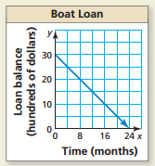
a) What is the slope of the line?

b) What does the slope represent?

c) What equation would represent this graph?

d) How much will you still owe after making payments for
14 months?

